VISVESVARAYA TECHNOLOGICAL UNIVERSITY

Jnana Sangama, Belagavi, Karnataka, India -590018

BACHELOR OF ENGINEERING
In
ARTIFICIAL INTELLIGENCE AND DATA SCIENCE
A Report on
“WATER DEFICIT AND SURPLUS BASINS IN INDIA”

Submitted by
MAREDDY CHARAN 1SJ22AD024

Under the Guidance of
Mr. Manjunatha N
Assistant Professor
Dept. of Civil


SJC INSTITUTE OF TECHNOLOGY
DEPARTMENT OF ARTIFICIAL INTELLIGENCE AND DATA SCIENCE
CHIKKABALLAPUR - 562101
2025-26

ABSTRACT

India is a country marked by immense geographical diversity, which results in highly uneven distribution of water resources. Some regions receive abundant rainfall and enjoy high river discharge, while others struggle with dry climates, low rainfall, and severe water scarcity. This report explores the concept of water surplus and water deficit river basins in India, analyzing their causes, characteristics, and distribution. It also discusses the importance of identifying such basins for effective water management, the factors influencing water availability in India, and the major reasons behind rising water stress. The report concludes by emphasizing the need for sustainable strategies to balance water availability across the country and ensure long-term water security.

- INTRODUCTION
Water is fundamental to human survival and economic development, and its availability determines the agricultural productivity, industrial growth, and ecological balance of any region. India, despite being endowed with an extensive river network and receiving significant monsoon rainfall, faces a serious challenge in its water distribution. Certain river basins receive heavy rainfall and are characterized by abundant water, while others remain chronically water-scarce. This imbalance occurs due to variations in geography, climate, river flow patterns, monsoon dependency, and human activities. As a result, some regions frequently experience floods due to excess water, whereas others face recurring droughts that affect livelihoods and agricultural output. The uneven distribution of water creates pressure on limited resources, leading to conflicts between states, overexploitation of groundwater, and increased vulnerability to climate change.
The identification of water deficit and water surplus basins is therefore essential for planning irrigation, managing drought-prone regions, controlling floods, and designing inter-basin water transfer projects that can help balance water availability across regions. Understanding these basins also supports policymakers in developing sustainable water management strategies, improving storage capacity, and promoting efficient water use practices. This report examines major surplus and deficit basins in India, explains the causes behind these patterns, and highlights their importance in India’s overall water resource management for future development and resilience.

WATER SURPLUS BASINS IN INDIA
Water surplus basins refer to regions where the availability of water significantly exceeds the demand. These basins receive high rainfall during monsoon seasons and often have extensive river networks originating from large catchment areas. The northern and northeastern parts of India, especially those influenced by the Himalayan mountain system, exhibit surplus water conditions due to the combination of monsoon rainfall and perennial river flow sustained by snowmelt.
The Brahmaputra Basin is considered the most water-rich basin in India, receiving some of the highest rainfall totals globally. Large parts of Assam and the northeastern states are covered by this basin, and the Brahmaputra River carries massive discharge throughout the year. Its constant flow and high rainfall make the basin one of the most surplus regions in the country, though it frequently experiences flooding. The Ganga Basin, stretching across northern India, is another major surplus region. The basin benefits from both monsoon rainfall and Himalayan snowmelt, supplying water throughout the year. This abundant water availability supports extensive agricultural activities across the Gangetic plains.
Among peninsular rivers, the Godavari Basin is the largest water-rich basin in southern India. Its wide catchment area and dependable monsoon rainfall ensure consistent river flow. Several major irrigation and hydropower projects rely on the Godavari River’s water resources. Similarly, the Mahanadi Basin receives stable rainfall across Odisha and Chhattisgarh, contributing to healthy river discharge and surplus water availability during most years. These water surplus basins are crucial for food production, hydroelectricity, and maintaining ecological balance.
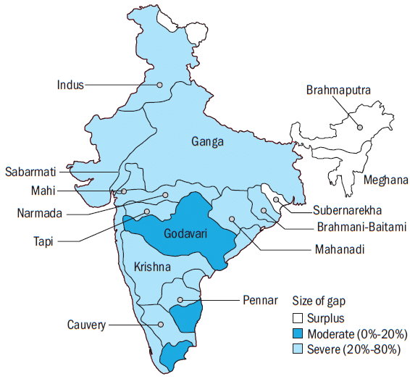
Fig. 1 Water Surplus Basins in India
The map presents the spatial distribution of major river basins across India according to their water availability status. It divides the river basins into three categories: surplus regions, moderately deficit regions, and severely deficit regions. The surplus areas include the Ganga, Brahmaputra, Mahanadi, and certain upper sections of the Godavari basin. These regions receive abundant monsoon rainfall, maintain high river discharge, and benefit from perennial water flow supported by large catchment areas and, in some cases, Himalayan snowmelt.
The moderately deficit areas represent basins where water availability is lower but not critically scarce. These include portions of the Krishna and Godavari basins where seasonal shortages occur because water demand—especially for agriculture—often exceeds supply during dry months. The severely deficit regions are concentrated in the southern parts of India, particularly the Cauvery and Pennar basins, where low rainfall, high evaporation rates, and heavy dependence on groundwater contribute to persistent water scarcity.
Overall, the map highlights the strong geographical disparities in India’s water resources. While northern and northeastern regions enjoy perennial rivers and substantial monsoon rainfall, the southern and western parts of the country frequently encounter drought-like conditions. This visual representation stresses the importance of adopting effective water management measures such as inter-basin water transfer, enhanced storage and recharge structures, and improved irrigation efficiency. Understanding these spatial variations is essential for planning irrigation, managing drought-prone areas, designing long-term water strategies, and ensuring sustainable water security across India.

WATER DEFICIT BASINS IN INDIA
Water deficit basins are those where water availability falls short of the demands of population, agriculture, and industry. These basins are mostly found in regions with low rainfall, dry climates, high evaporation rates, and limited surface water storage. Many of these areas rely heavily on groundwater, which often leads to depletion due to overuse.
The Cauvery Basin frequently experiences water shortages due to uneven rainfall distribution, growing agricultural demands, and inter-state disputes over water sharing between Karnataka and Tamil Nadu. Although parts of the basin receive moderate rainfall, the overall demand far exceeds supply, resulting in periodic droughts. The Krishna Basin also suffers from deficit conditions because rainfall is insufficient to meet the expanding irrigation needs across Karnataka, Telangana, and Andhra Pradesh. With large populations depending on agriculture, the pressure on this basin is immense.
The Pennar Basin is one of the driest river basins in India. Covering regions of Andhra Pradesh and Tamil Nadu, this basin receives very low annual rainfall and has limited catchment capacity, making it highly drought-prone. The regions of Kutch and Saurashtra in Gujarat face acute water scarcity because they lie in semi-arid and desert climatic zones. These areas receive extremely low rainfall and have minimal perennial river sources, forcing communities to depend heavily on groundwater. Similarly, inland regions of Rajasthan form some of the driest areas in the country, where rainfall is scarce and river flow is almost negligible. These deficit basins represent India’s most water-stressed zones, severely affecting agriculture, livestock, and livelihood.
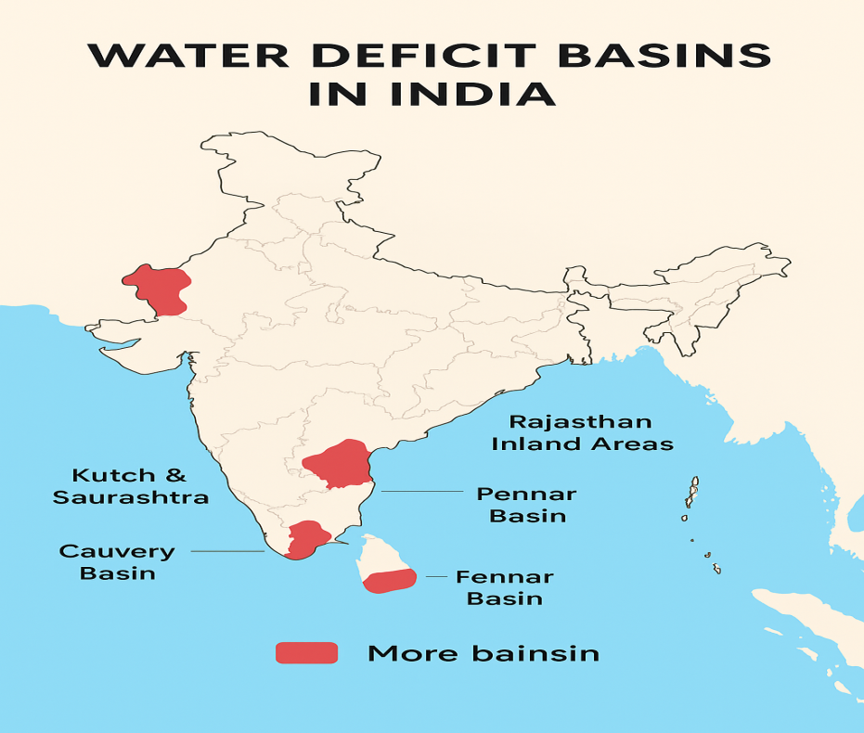
Fig. 2 Water Deficit Basins in India
The map highlights the major water deficit basins in India, marked in red to represent regions facing severe water scarcity. These areas include the Cauvery Basin, Pennar Basin, and the Fennar region in southern India; the Kutch and Saurashtra region in Gujarat; and the inland regions of Rajasthan. These basins typically experience low and highly variable rainfall combined with arid or semi-arid climatic conditions, resulting in very high evaporation rates. Due to these climatic limitations, water availability remains consistently low throughout the year. In many of these regions, agriculture and domestic needs rely heavily on groundwater, leading to overextraction and rapid depletion of aquifers. The situation is further aggravated by limited surface water resources and inadequate storage infrastructure, which restrict the ability to capture and retain rainfall during the monsoon season.
The map also illustrates the geographic clustering of water-stressed basins, particularly across western and southern India. These deficit regions frequently experience droughts, reduced agricultural productivity, and increasing pressure on already limited water supplies as population and industrial activities continue to grow. Identifying these basins is crucial for implementing effective water management strategies. Overall, understanding the spatial distribution of water deficit basins is essential for addressing regional disparities in water availability and guiding national water resource management policies.

DIFFERENCE BETWEEN SURPLUS AND DEFICIT BASINS

Parameter | Water Surplus Basins | Water Deficit Basins
Rainfall | Receive high and reliable monsoon rainfall | Receive low, irregular, or highly variable rainfall
River Flow | Rivers have strong, perennial flow with high discharge | Rivers are seasonal and weak with low discharge
Climate | Mostly humid, tropical or sub-tropical | Mostly arid or semi-arid with high temperatures
Water Availability | Water availability exceeds domestic, agricultural, and industrial demand | Water availability is lower than the required demand
Examples | Brahmaputra, Ganga, Godavari, Mahanadi | Cauvery, Krishna, Pennar, Kutch–Saurashtra, Rajasthan
Major Issues | Frequent floods and overflow of rivers | Droughts, scarcity, and groundwater depletion
Groundwater Condition | Good recharge due to high rainfall | Poor recharge and heavy dependence on groundwater
Agricultural Impact | High irrigation potential and surplus flow supports cultivation | Water shortages restrict cropping intensity and productivity
Runoff & Storage | High surface runoff and large catchment areas | Very limited runoff and small catchment regions

Table 1 DIFFERENCE BETWEEN SURPLUS AND DEFICIT BASINS

IMPORTANCE OF IDENTIFYING SURPLUS AND DEFICIT BASINS
Understanding which basins are surplus and which are deficit is essential for effective water management at both state and national levels. This knowledge helps in designing water storage systems such as reservoirs, check dams, and canals in surplus regions to harness excess water during the monsoon. In deficit areas, it aids in planning water conservation measures, improving irrigation efficiency, and introducing drought-resistant crops. Identifying these basins also plays an important role in developing river-linking projects that aim to transfer water from surplus basins to deficit ones, thereby reducing regional imbalances.
Furthermore, such classification assists government agencies and policymakers in crafting long-term strategies for flood control and drought mitigation. It also supports sustainable development initiatives by promoting the judicious use of available water resources. Overall, understanding surplus and deficit basins allows India to manage its limited water resources more efficiently and ensure equitable distribution across different regions.

FACTORS INFLUENCING WATER AVAILABILITY IN INDIA
- Dependence on Monsoon Rainfall: India relies heavily on the southwest monsoon, which contributes nearly 80% of the annual rainfall. Any fluctuation—such as delayed onset, weak intensity, or uneven distribution—directly impacts water availability in rivers, lakes, reservoirs, and groundwater sources.
- Impact of Monsoon Variability: A strong monsoon leads to abundant water flow and often floods in surplus regions, whereas a deficient monsoon results in drought-like conditions in already water-scarce areas. This seasonal dependency makes India’s water supply unpredictable.
- Geographical Diversity of River Systems: Northern rivers such as the Ganga and Brahmaputra are perennial because they receive continuous flow from Himalayan snowmelt and glaciers. In contrast, peninsular rivers like the Godavari, Krishna, and Cauvery are rain-fed and seasonal, making their flow highly dependent on monsoons.
- Rapid Population Growth: Rising population levels increase water consumption in households, agriculture, and industries. This growing demand places excessive pressure on existing surface and groundwater resources.
- Urbanisation and Industrial Expansion: Urban centres and industrial zones require large quantities of water for daily operations. The rapid expansion of cities has intensified water extraction, often exceeding natural recharge rates.
- Overexploitation of Groundwater: Excessive and unregulated pumping of groundwater—especially in agricultural regions—has led to continuously declining water tables. Many states now face critical groundwater depletion.
- Inefficient Water Management Practices: Traditional irrigation methods such as flood irrigation waste large volumes of water. In addition, poor maintenance of canals, leakage in pipelines, and inefficient distribution systems contribute to major water losses.
- Inadequate Storage Infrastructure: Several river basins lack sufficient reservoirs and storage systems to capture excess monsoon runoff. As a result, large amounts of potential water supply flow unused into the sea during the rainy season.
- Climate Change Effects: Changing climate patterns have increased the unpredictability of rainfall, caused more frequent droughts and floods, and raised temperature levels, all of which reduce reliable water availability.

CAUSES OF WATER STRESS IN INDIA
Water stress in India is caused by a combination of natural factors and human activities. One of the most significant contributors is the overexploitation of groundwater. India is the largest consumer of groundwater in the world, mainly because its agriculture sector relies heavily on tube wells and bore wells. Continuous withdrawal without adequate recharge has caused groundwater levels to drop sharply in many states.
Uneven rainfall distribution is another major cause of water stress. Western, central, and southern states frequently experience rainfall deficits, while northeastern and eastern regions receive excessive rainfall. Industrialization has also played a role, as industries require large quantities of water for production and often release untreated waste into water bodies, further reducing available clean water. Agricultural practices such as flood irrigation and the cultivation of water-intensive crops like rice and sugarcane worsen the situation in areas with limited water availability. Climate change has intensified the problem by causing unpredictable rainfall patterns, rising temperatures, and more frequent droughts and floods.

CONCLUSION
India’s water resources present a paradox: despite being endowed with major rivers and significant rainfall, the country faces severe water scarcity in many regions because of uneven distribution. Water surplus basins like the Brahmaputra, Ganga, Godavari, and Mahanadi benefit from abundant rainfall and perennial rivers, while deficit basins such as the Cauvery, Krishna, Pennar, Kutch, Saurashtra, and Rajasthan suffer from low rainfall, high evaporation, and growing demand. This imbalance has created significant challenges for agriculture, industry, and domestic use.
To address these issues, India must adopt sustainable water management practices, focus on improving irrigation efficiency, promote rainwater harvesting, and construct adequate storage and recharge structures. Inter-basin water transfer projects must be carefully planned to ensure ecological balance while meeting the needs of deficit regions. With proper policies, technological innovations, and public participation, India can bridge the gap between surplus and deficit basins and move toward long-term water security.

